Regular Program -Cochin-Munnar-Thekkady-Alleppey-Kovalam (08/09days)

Day 01 – Arrive Cochin/ Transfer to the hotel
On arrival at Cochin met and transferred to your hotel. Rest of the day at leisure - Overnight at hotel
Cochin is situated on the south-west coast of the Indian peninsula . Its strategic importance over the centuries is underlined by the sobriquet Queen of the Arabian Sea. Informally, Cochin is also referred to as the Gateway to Kerala
Rest of the day is at Leisure or explore Marine drive

Day 02 – Sightseeing of Cochin
Morning Sightseeing of Cochin includes Mattancherry Dutch Palace,Jewish Synagogue,Chinese fishing nets & St Francis church Evening watch Kathakali Performance (dance drama of Kerala) in a theatre.-Overnight at Hotel
Chinese fishing Net
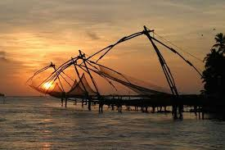

Jewish Synagogue
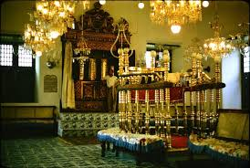

Kathakali Performanace
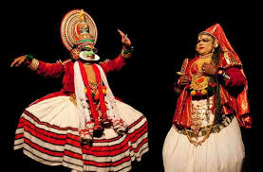

Day 03– Transfer to Munnar ( 04hours)
Munnar is a beautiful peaceful hillstationcovered with unending expanse of tea plantations with an altitude ranging from 1600 to 1800 metres above sea level. –Overnight at Hotel

Day 04 – In Munnar
Munnar Sightseeing - Tea Museum,Mattupetty Dam,Eravikulam National park, Top station & Devikulam are the main attractions –Overnight at Hotel

Tea Plantations

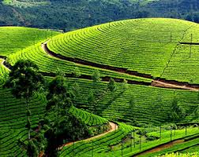

Eravikulam National Park

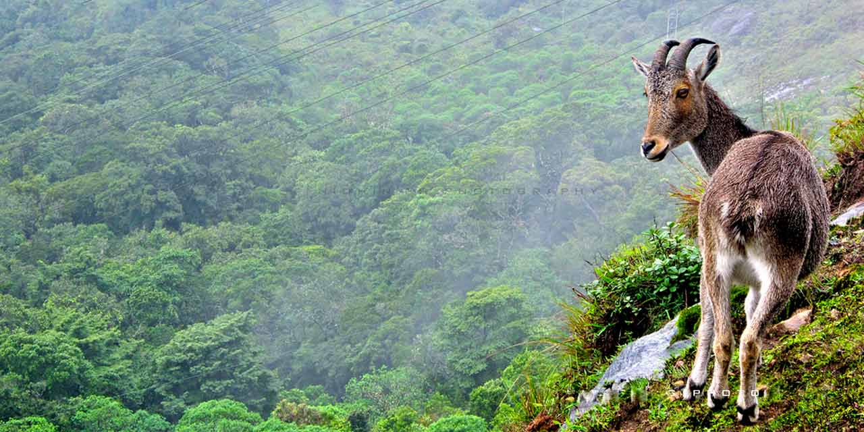

Mattupetty dam

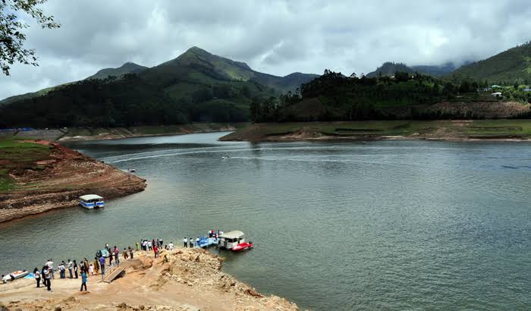

Day 05- Transfer to Thekkady ( 03hours)
One of India’s major sanctuary area and the spice garden of Kerala .The Sanctuary offers a lovely and comfortable way to see the animals– Thekkady
Enjoy the activities in Periyar are Optional- trekking, gameviewing by boat,spice garden visit ,& elephant interaction
Overnight at hotel

Day 06– Transfer to Alleppey ( 04 hours)
Alleppey is one of the most important tourist centers in the state, with a large network of inland canals earning it the sobriquet "Venice of the east".
Kettuvalloms or Houseboats (Riceboats) are country boats that were used in the early days for the transport of goods from the isolated interior villages to the town –Overnight in House Boat
Houseboat
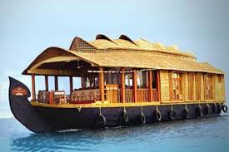

Day 07 – Transfer to Kovalam - enroute visiting Trivandrum - ( 04 hours)
Trivandrum is the capital city of Kerala. Kovalam was the one of the fisherman Village changed one of the famous beach for relax – Sightseeing of Trivandrum -– Napier Museum, Kuthira Malika Palace, Sree Chitra Art gallery Chalai market etc
Kovalam Beach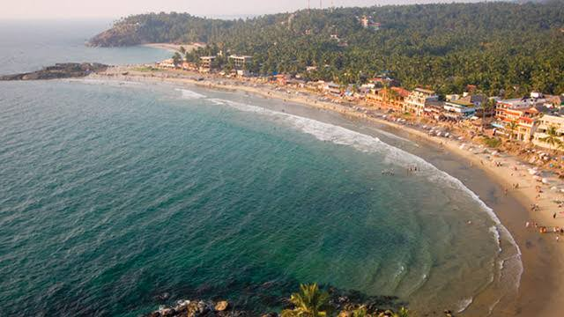
Napier Museum

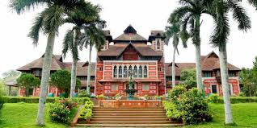

Kuthira Malika

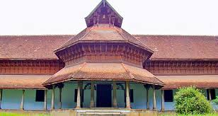

Day 08 – At Leisure - Kovalam Beach Hotel

Day 09–Dep transfer to Trivandrum Airport

After early breakfast proceed to Trivandrum Airport to catch flight back Home

End of the tour-------------+

