Regular Program 2 -Cochin-Alleppey-Kumarakom- Kovalam – 06/07days
Day 01: Arrive at Cochin Airport Met and transfer to your hotel at Fort Cochin ( 01.5 hr drive)Overnight in a Hotel Cochin is situated on the south-west coast of the Indian peninsula. Its strategic importance over the centuries is underlined by the sobriquet Queen of the Arabian Sea. Informally, Cochin is also referred to as the Gateway to Kerala.
Day 02:- Sightseeing of Cochin – Overnight in a Hotel
Morning Sightseeing of Cochin includes Mattancherry Dutch Palace, Jewish Synagogue, Chinese fishing nets & St Francis church. Evening watch Kathakali Performance (dance drama of Kerala) in a theatre.

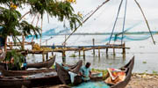

Day 03:-Transfer to Alleppey ( 01.5hr drive)-Board and overnight in Houseboat with all meals Alleppey is one of the most important tourist centers in the state, with a large network of inland canals earning it the sobriquet "Venice of the east".
Kettuvalloms or Houseboats (Riceboats) are country boats that were used in the early days for the transport of goods from the isolated interior villages to the town

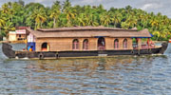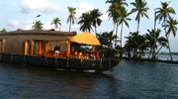

Day 04:- Transfer to Kumarakom (01 hr drive)- Overnight in a Lake Resort
The village of Kumarakom is a cluster of little islands on the Vembanad Lake, and is part of the Kuttanad region. The bird sanctuary here, which is spread across 14 acres is a favourite haunt of migratory birds and an ornithologist's paradise. PM Sightseeing of Kumarakom
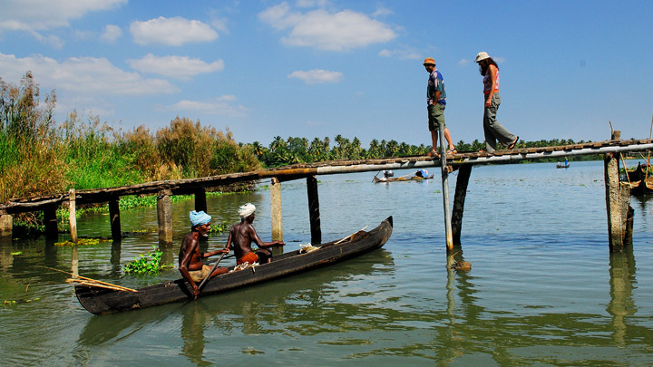
Day 05 :- Transfer to Kovalam ( 04 hour drive) Overnight in a Beach hotel Trivandrum is the capital city of Kerala. Kovalam once was a fisherman Villages which later changed as one of the famous beaches for relaxation.

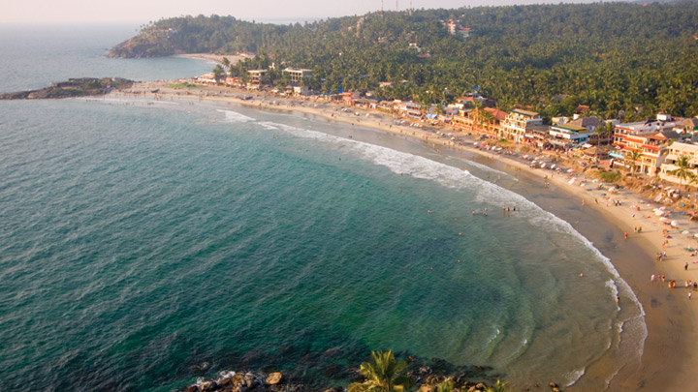
Day 06 :- Sightseeing of Trivandrum-Overnight in a Beach Hotel Thiruvananthapuram (Trivandrum) is the capital city of Kerala. Museum Of History & Heritage, Napier Museum, Puthenmaliga Palace Museum & Padmanabhaswamy Temple are the main attractions

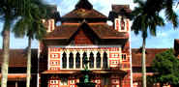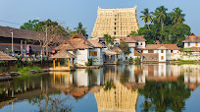

Day 07:- Departure transfer to Trivandrum Airport
After an early Breakfast proceed to Trivandrum Airport to Catch flight back home

